

**FPT ACADEMY INTERNATIONAL**

**FPT – APTECH COMPUTER EDUCATION**



**Sanjalika Water Park**

**Team:** Group 6

**Class:** T1.2010.E0

Tran Manh Hung (team leader) Student1283034

Tran Tang Khai Hoai Student1280926

Nguyen Vo Hoang Khanh Student1280962

**Start date:   25-Dec-2020**

**End date: 26-Jan-2021**

**Instructor:**

Le Mong Thuy

**Problem Statement**

Sanjalika Water Park is definitely an ultimate and out of the world source of entertainment. Decorated by mermaids, other statues, the Sanjalika Water park has largest cave and swimming pool area of modern technology a kind of place for thrills and fun. At Sanjalika Water park there is lot of water rides which are very exciting and thrilling. You need to develop a website of ‘SANJALIKA WATER PARK’.

The website is to be developed for the Windows Platform using HTML5, JavaScript and Geolocation. The site should work well in all leading browsers including Chrome, IE, Firefox etc.

**CUSTOMER'S REQUIREMENTS SPECIFICATIONS (CRS)**

**Client: *Sanjalika Water Park***

**Business/Project Objective:**

Provide users interesting information about Sanjalika Water Park.

Enable users to book features.

**Input to the system:**

* + - * Searching activities, food, entertainment areas, depend on price, brand and information about Sanjalika Water Park.
      * Booking features, eg. Buy ticket,…
      * Feedback about the experience while they spend times at there.
      * Register members on website.

**Output from the system:**

* Displaying result of the products that the user is looking for, including images of its.

- Success/error message from website to web visitors.

**Hardware/ Software Requirements**

**Hardware**

* A minimum computer system that will help you access all the tools in the courses is a Pentium 166 or better
* 64 Megabytes of RAM or better

**Software**

* Notepad/HTML editor
* Dreamweaver
* IE 5.0/ Netscape 6.0

# Diagram Funtion

**HOME**

**Activities**

**Contact us**

**Information**

**Login**

**Ticket**

**TASK SHEET REVIEW 1**

|  |  |  |  |  |  |  |  |
| --- | --- | --- | --- | --- | --- | --- | --- |
| **Project Ref. No.:**  **Water Park** **System/01** | | **Project Title:** | **Activity Plan** **Prepared** **By:** | **Date of Preparation of Activity Plan:** | | | |
| **Sr.No.** | **Task** | **Actual Start** **Date** | **Actual** **Days** | **Team** **Mate** **Names** | **Status** |
| 1 | Problem definition | Water Park | Hung | 27/12/20 | 1 | Hung | Completed |
| 2 | Requirement specification | 27/12/20 | 1 | Khanh | Completed |
| 3 | Funtion diagram | 27/12/20 | 1 | Hoai | Completed |
| 4 | Tasksheet review 1 | 27/12/20 | 1 | Hoai | Completed |

|  |  |
| --- | --- |
| **Date:** | |
| Signature of Instructor:  **Ms. Le Mong Thuy** | Signature of Team Leader:  **Hung** |

**TICKET PAGE**

**HOME PAGE**

**ACTIVITIES**

**ACTIVITIES PAGE**

**CONTACT US**

**CONTACT PAGE**

**INFORMATION**

**INFORMATION PAGE**

**LOGIN**

**LOGIN PAGE**

**TICKET**

**SITE MAP**

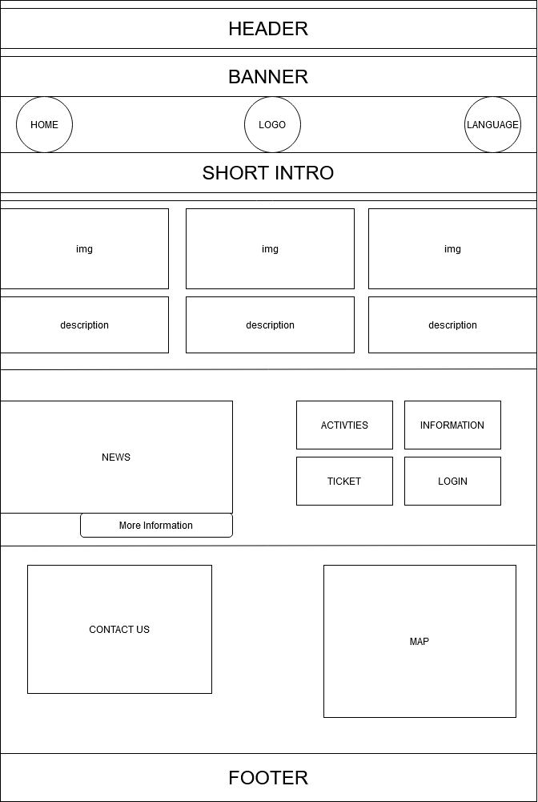

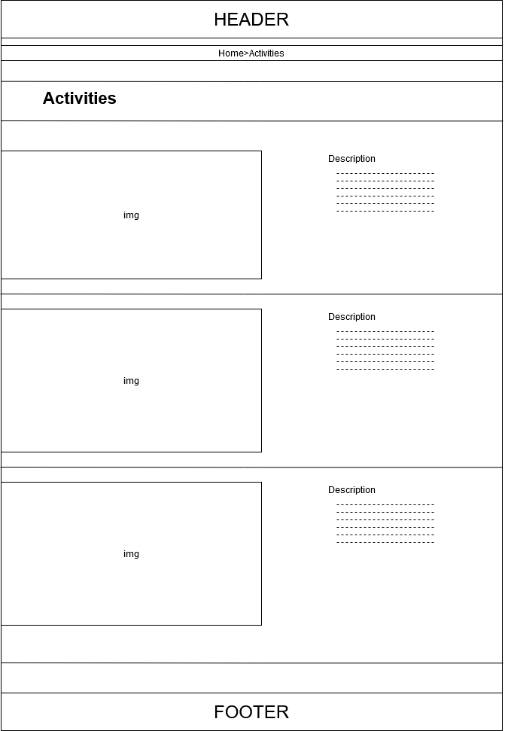

# 

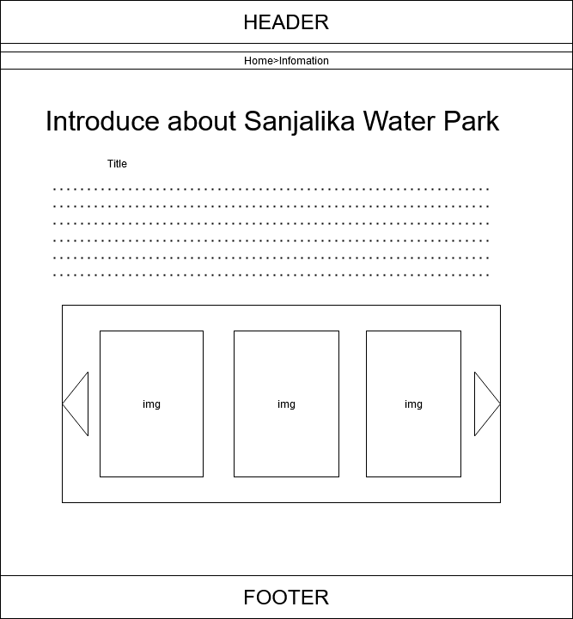

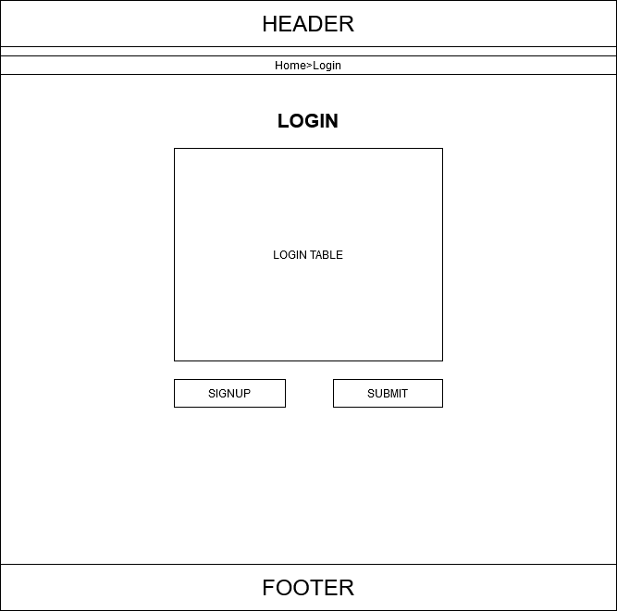

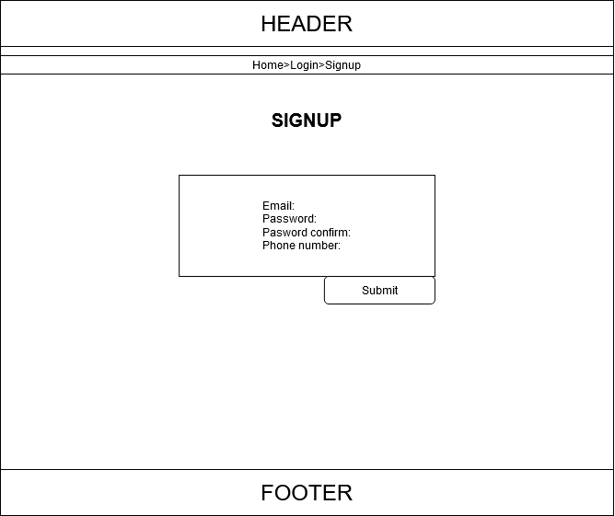

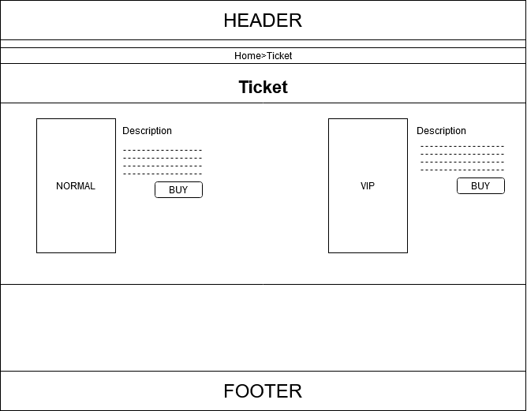

|  |  |  |  |  |  |  |  |
| --- | --- | --- | --- | --- | --- | --- | --- |
| **Project Ref. No.:**  **Water Park** **System/01** | | **Project Title:** | **Activity Plan** **Prepared** **By:** | **Date of Preparation of Activity Plan:** | | | |
| **Sr.No.** | **Task** | **Actual Start** **Date** | **Actual** **Days** | **Team** **Mate** **Names** | **Status** |
| 1 | Site map | Water Park | Hung | 1/1/21 | 1 | Hung | Completed |
| 2 | Mock Layout | 1/1/21 | 1 | Khanh | Completed |
| 3 | Tasksheet review 2 | 1/1/21 | 1 | Hoai | Completed |

|  |  |
| --- | --- |
| **Date:** | |
| Signature of Instructor:  **Ms. Le Mong Thuy** | Signature of Team Leader:  **Hung** |

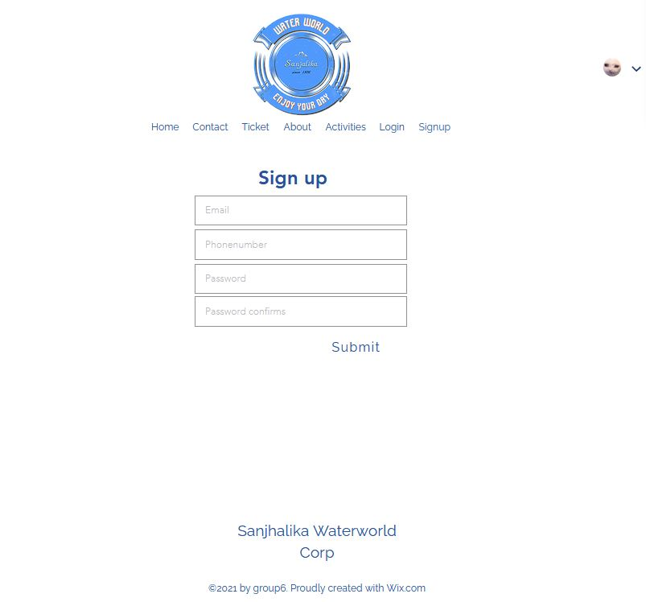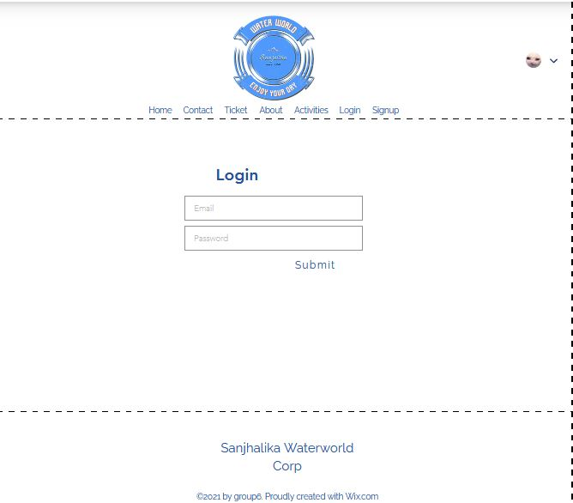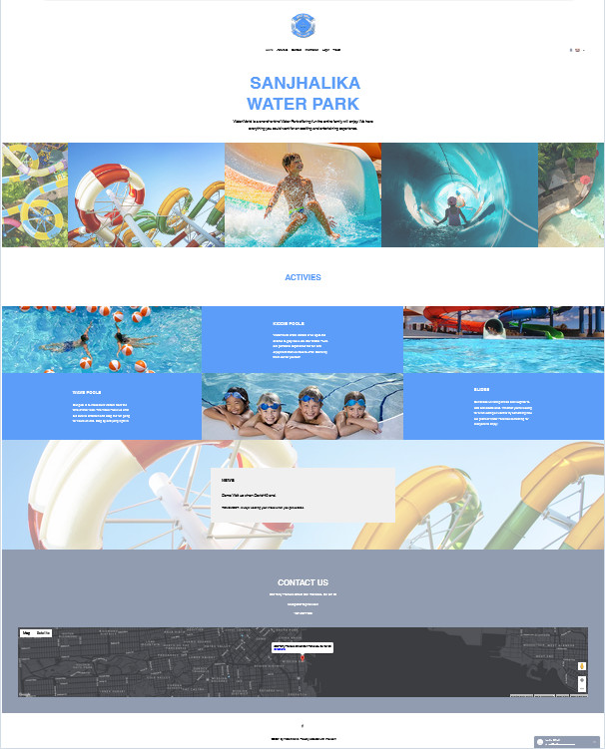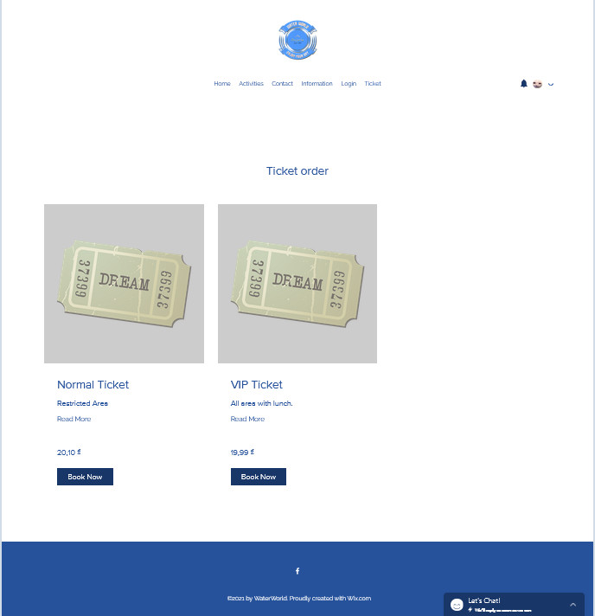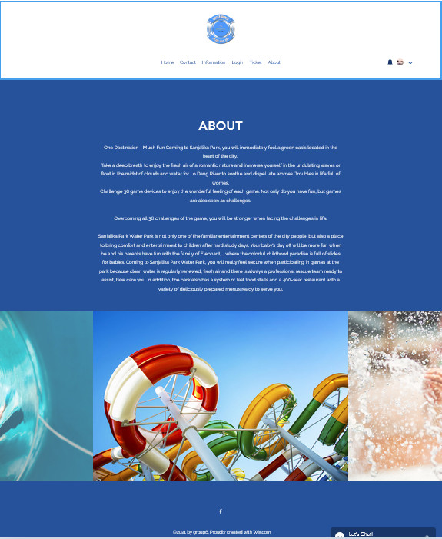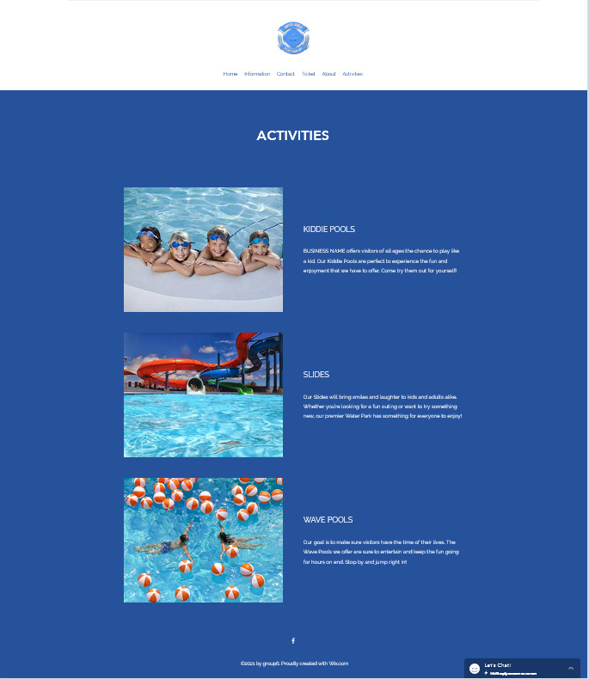

**TASK SHEET REVIEW 3**

|  |  |  |  |  |  |  |  |
| --- | --- | --- | --- | --- | --- | --- | --- |
| ***Project Ref. No.:***  ***eP/Advertisement Portal Management System/01*** | | ***Project Title:*** | ***Activity Plan Prepared By:*** | ***Date of Preparation of Activity Plan:*** | | | |
| ***Sr.***  ***No.*** | ***Task*** | ***Actual Start***  ***Date*** | ***Actual Days*** | ***Team Mate***  ***Names*** | ***Status*** |
| *1* | *Home page* | *Water World* | *hung* | 3-Jan-21 | *1* | *Khanh* | *Completed* |
| *2* | *Activities* | 4-Jan-21 | *3* | *Khanh* | *Completed* |
| *3* | *Ticket* | 7-Jan-21 | *2* | *Khanh* | *Completed* |
| *4* | *About Us* | 10-Jan-21 | *1* | *Hung* | *Completed* |
| *5* | *Contact* | 12-Jan-21 | *2* | *Hung* | *Completed* |
| *6* | *Sign in / Sign up* | 14-Jan-21 | *3* | *Hoai* | *Completed* |
| *7* | *Login* | 14-JAn-21 | *2* | *Hoai* | *Completed* |

|  |  |
| --- | --- |
| **Date:** | |
| Signature of Instructor:  **Ms. Le Mong Thuy** | Signature of Team Leader:  **Hung** |